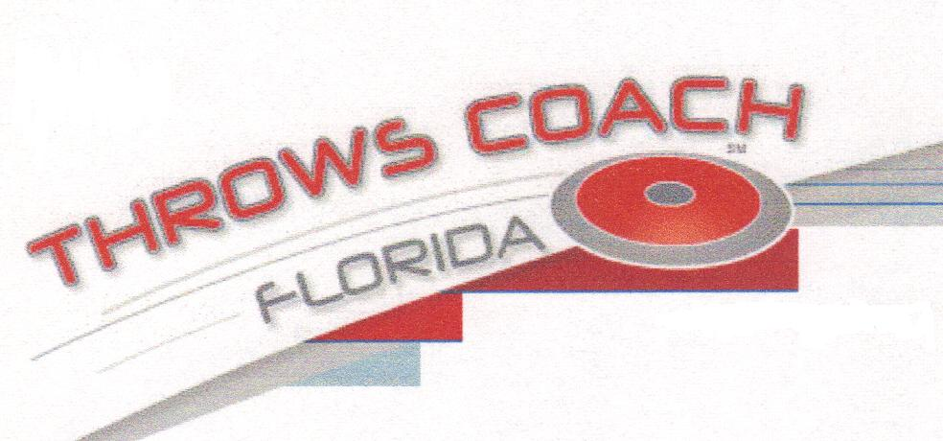

THROWS COACH FLORIDA

WEEKLY ONE-THROW COMPETITIONS

Sunday 4th December 2010

1. Zack Larrabee 47.88/157’1”
2. Nick Kirk 33.50/109’11’
3. Mason Lasater 30.79/101’
4. Carl Womack 25.76/84’5”
5. Richie Lovell ND
Laura Kirk ND

